Kingston Town Mosaic Walkabout
Save The World Club is a local Kingston charity and we make community mosaics to beautify the local are, often covering up graffiti black spots with our work.
Start:
John Lewis anniversary mosaic is on the outside of the JL department store on riverside.
This fabulous mosaic depicting three iconic buildings on the Kingston riverfront was made to celebrate the 20 the Anniversary of John Lewis during 2010. More than 300 local people took part including 200 John Lewis partners, 16 young offenders, and many volunteers. It took 3 weeks to make and contains thousands of pieces of glass and ceramic tile- each one individually cut to fit perfectly.
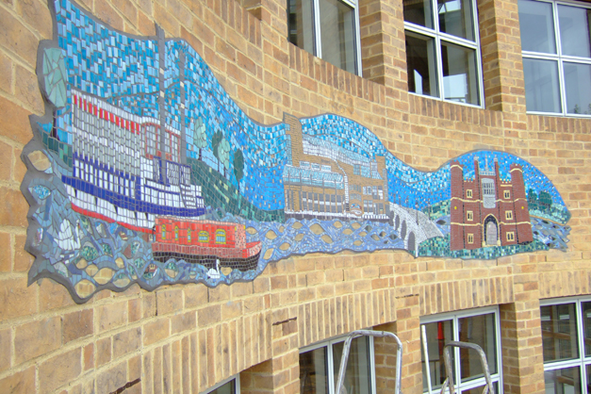
Walk from the riverside to the junction of Skerne Road and Canbury passage ( less than 5 minutes). Here you will find the Hunderstwasser Mosaic. More than 1800 local people came together over hundreds of mosaic making sessions to work on this project . It took over two and a half years to complete and is the largest of its kind in the UK. The work is based on the amazing buildings designed by Austrian Artist Hunderstswasser. 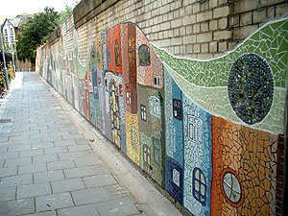
Having walked the length of the passage its a short hop over to the junction of Richmond road and Kingsgate Road , to Kingston Art College
Here you will find “ Circles” another community project made in our workshops over a period of 6 months and installed to improve an ugly and graffiti covered wall .The shopkeepers and local residents have been very positive about how this mosaic has improved the local streetscape. 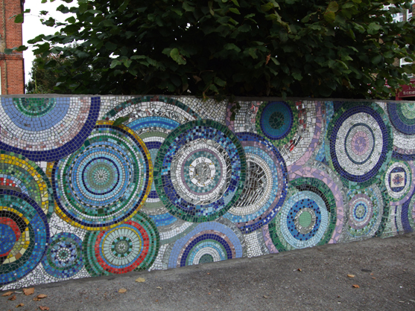
Cross over the Richmond road and continue up Acre Road to Elm Road Playground ( accessed through Warwick House housing estate)
Elm Road playground . The mosaic uses subject matter from the local area and mixes it with fantasy elements to create a wonderful, colourful piece of art. There are 12 panels in all it brightens up the playground and prevents graffiti .( Tiger below is one of 12 panels )
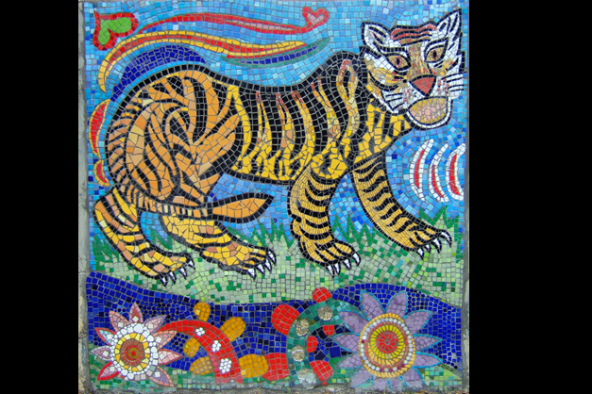
Walking from Elm road , head back towards Kingston station and you will see the first large mosaic made by STWC in 2003, ‘Views from a Train’

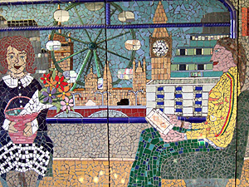
One of the panels , made in 2003 , in conjunction with the local community and again made to cover an awful graffiti hotspot , which at the time was complete with bloodied handprints on the wall as well!.
Walk from Kingston Station to Castle Street, about 3 minutes and there you will see our Muybridge Mosaic.
STWC created a 21st century perspective on the photographer Edwaerd Muybridge, a Kingston resident . This work was commissioned to celebrate his centenary and involved local schools, residents and our lovely volunteers. We cut many over 20 metres of mirror to create this fantastic reflective art work . We love it and hope you do to.
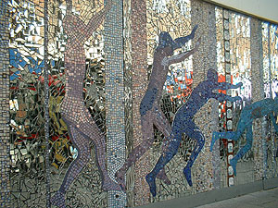
Our workshop is very close to Kingston town centre, so if the mosaics have inspired you to make your own, or to volunteers please have a look at our website www.savetheworldclub.org or email me kim@savetheworldclub.org

